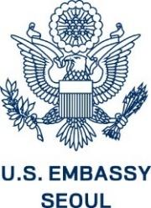 | U.S. Embassy Seoul  Public Diplomacy Section  American Diplomacy House  Academy Program  Application 2022-2023 | 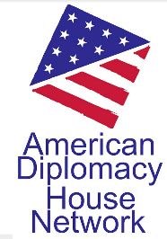

Thank you for your interest in participating in the U.S. Embassy’s American Diplomacy House Academy Program. If you would like to be considered for this dynamic and impactful new cohort-based program, please complete the following questions. We look forward to reviewing your application, and questions can be emailed to ADHSeoul@state.gov

Applicant Information:

- Name (in Korean):
- Name (in English): (eg. Hong Gil-dong)
- Name of the University/College:
- Major:
- Academic Year:
(Note: 2022년 하반기 기준 2학년 2학기일 경우, 2-2로 기입/ 휴학생은 직전 학기와 함께 휴학 중이라고 명시)
- Mobile Phone Number: (eg. 010-1234-5678)
- Email:

In the space below, please complete the following questions
(Format font: Times New Roman, 12 font size)

- Please explain why you would like to be considered for the American Diplomacy Academy program. (In a maximum of 400 words)

- Please share with us what you expect to learn from this program. (In a maximum of 200 words)

Available Dates for Interview:

- Please note that the dates are subject to change.
- After document screening, selected applicants will be contacted separately.
 | Please select all that apply with mark X.
 | Morning | Afternoon
Week 3
August 16 (Tuesday)
August 17 (Wednesday)
August 18 (Thursday)
August 19 (Friday)
Week 4
August 22 (Monday)
August 23 (Tuesday)
August 24 (Wednesday)
August 25 (Thursday)
August 26 (Friday)

Important Notes:

- We accept application form via email only. Please submit to ADHSeoul@state.gov by August 7, 2022.
- Subject line of the email and name of application form should be ‘Academy Program 지원자-Your name in Korean (eg. Academy Program지원자-홍길동).
- MS word (.docx) or PDF format is only acceptable. Hangul saved document (.hwp) is not acceptable.

